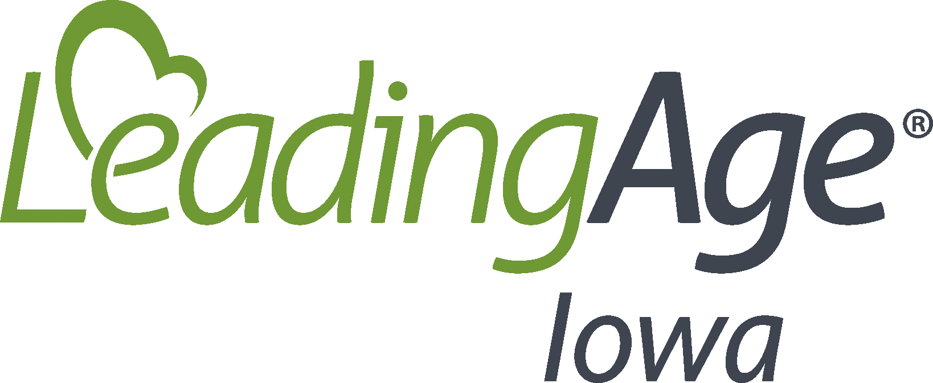
Annual Review of the Infection Prevention and Control Program

Date Implemented:
Review/Updated Date:
Policy
[Enter Facility Name] will at least annually review and/or update all components of the Infection Prevention and Control Program to remain in compliance with federal requirements of participation as well as ensuring that the facility is following the latest guidance from the Centers for Disease Control (CDC) and the Iowa Department of Public Health (IDPH).
Procedures
The Infection Preventionist will review and update [enter facility name]’s IPCP annually and as needed including:
- All policies and procedures established.
- Worksheets for infection surveillance among the residents, staff, volunteers, and visitors.
- Reportable infections as identified by the CDC and IDPH, including process for reporting.
- The process for inclusion of the Infection Prevention and Control Program into the facility’s QAPI and QAA committee meetings.
- The process for education of all staff related to Infection Prevention and Control Program.
- The process for competency assessments to assure that established Infection Prevention and Control Program procedures are being followed as developed.

Resources:
Appendix PP - November 22, 2017 (cms.gov) – F880

