**How to Apply for a NEW license**

Updated 02/2022

To access the online services web site please go to: <https://amanda-portal.idph.state.ia.us/ibpl/portal/#/dashboards/index>

In order for the website to function properly, you will need to enable pop-ups. If you do not know how to enable pop-ups, you can visit the following link to see how it is done on your specific device (Please note that this website is NOT part of the State of Iowa and we do not update the information on this website, if you are unable to find your specific browser information, please do an online search for your device) <https://www.isc.upenn.edu/how-to/configuring-your-web-browser-allow-pop-windows>

**\*If you have never signed on before you will need to create yourself an account\***

Select ‘Create an Account’ from left side of the blue and white box and follow the prompts on the screen to complete the process.

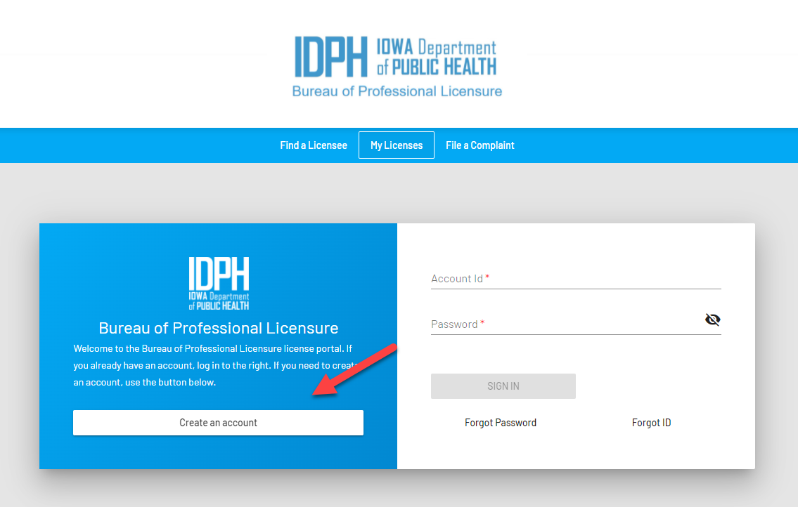

For questions regarding accounts call the State of Iowa Service Desk at 515-281-5703 or 800-532-1174.

**Make sure you write down all account information, you will need it every time you log in.**

Once the account is created, OR you already have an @IOWAID, enter your @iowaid (Account id) and password you created on the right hand side of the blue and white box (make sure you end your account id with @IOWAID, that *IS* part of your Account ID)

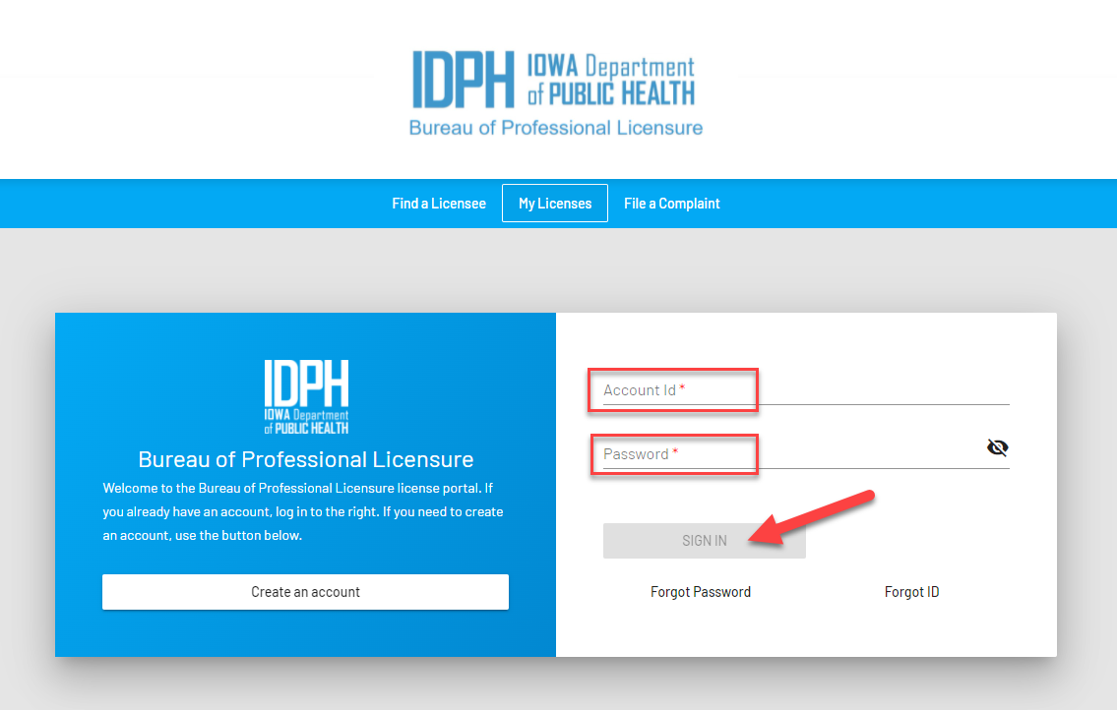

Please note the options at bottom of the white side of the box:

*If you have forgotten your ID, click on Forgot ID

*If you have forgotten your password, click Forgot Password

(Both of these options will walk you through the process of retrieving your account id and resetting your password. **If you no longer have access to an email that you may have used to set up an account in the past, you may use your current email and create a new account**)

Next you will enter your Social Security number and Date of birth

**Please make sure you have entered it correctly. This will be the way you are linked to your account in the future.**

Once you have entered that, **click Register**,It will take you to the ‘My profile’ page.

Please ensure that you have enabled popups for this site as you will not be able to continue without having those allowed.

1. On the ‘My Profile’ page enter your name, email address and contact information. (If you have previously signed in and have already created an account before, the information should be populated) Once all mandatory fields have been entered click ‘Save Account Details’ at the bottom of the page

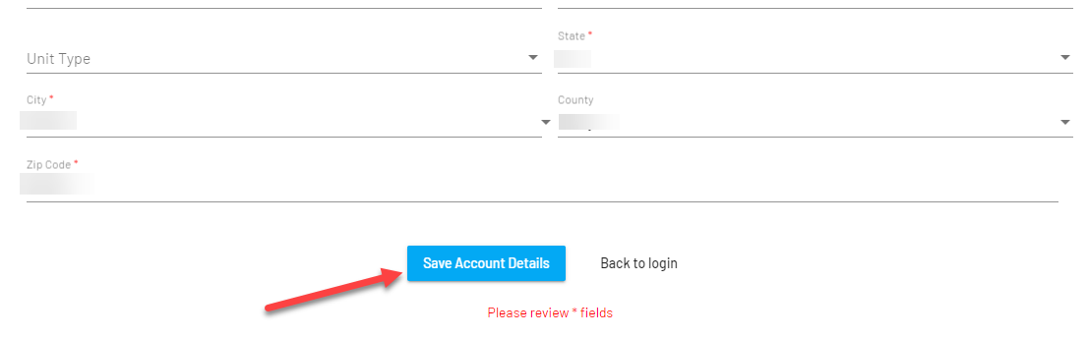

1. If you are going through the process of creating your account, you will then receive a popup that will let you know that you will now be redirected to the login page. You will need to re-enter your account ID and password to complete the process. (If you have signed in before it will not take you through this step again)

Click Continue.

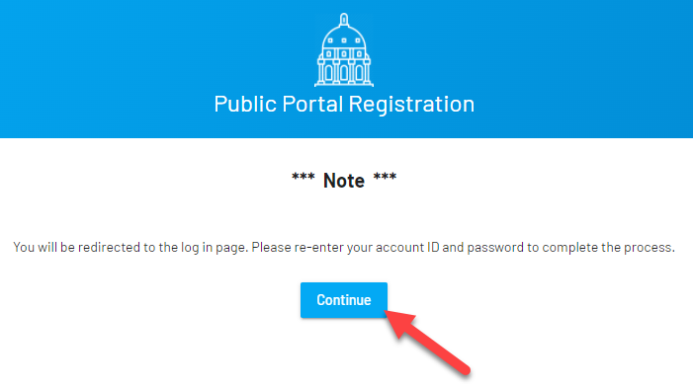

1. Please enter your @IOWAID and password and click on SIGN IN. It will again take you to the My Profile page, which you just entered your contact info. Check it over to make sure there are no errors (make corrections if needed). If everything looks good, click Submit at the bottom of the page.
2. You will be directed to the next page that will indicate that the profile has been updated successfully. In the box you will see how your name and address will appear on any documents. If you need to make corrections click on Update My Profile below the box. It will take you back to the My Profile Page. Once corrections are complete hit Submit. If everything looks ok, you can click on Apply for a License.
3. Now you can click on Apply for License:

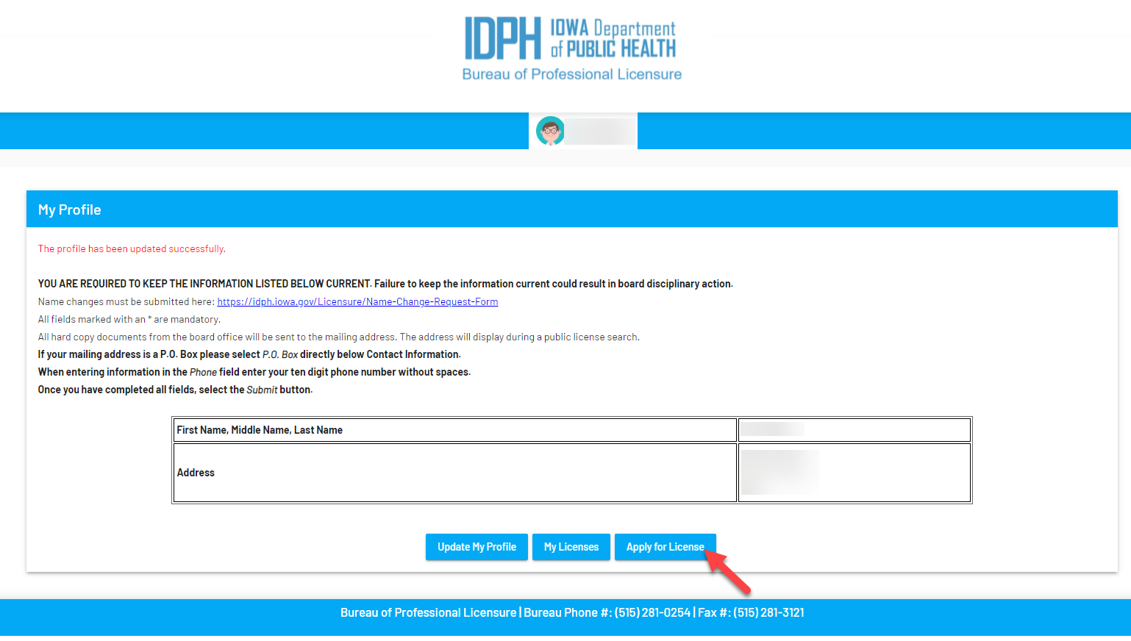

1. Please select the appropriate Board of the license you wish to apply.

It will then allow you to choose the license type. Once you have done both click continue.

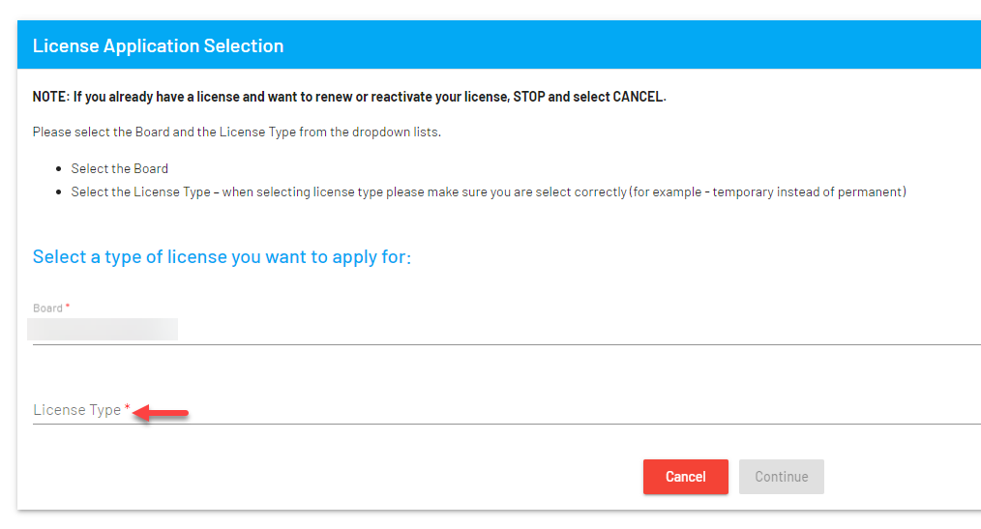

1. Complete the application questions.  All fields, even those which aren’t required at submission, should be completed. It will not let you proceed if required items are left blank. Required fields are indicated with a (*)

>>>>If applying for a salon license and you answered yes to a change in address or change in ownership, the previous establishment information IS required to be entered to be able to continue. (previous establishment name and license #)

Option to: Upload Attachment: You may not have anything to attach at this time, which is fine. Supporting documentation can be uploaded 24 hours a day, 7 days a week. Refer to the Application Guidelines to determine if a document can be submitted by the applicant or must come directly from an outside agency.

1. If all required fields are populated, you will have the option to click Next.
2. For certain professions you will be directed to an additional page for further information needed. If taken to this extra page, enter the requested information and click Continue at the bottom of the page.
3. You will now attest to your answers, after reading, you may click ‘Yes I Agree’
4. Click on ‘Pay now’ using MasterCard, VISA, Discover, or American Express card. You will need to click on CONTINUE and then will need to click on CONFIRM before the payment will be processed. Once the payment is processed, you will receive a Confirmation page that will give you your confirmation number. You can print or save this page for your records. Once you have what you need, you can click on Continue. The system will now direct you to another payment receipt. You can print (or save to your computer). Once you are done looking at it, click Done.

You will receive an email confirming receipt of your payment and a separate email confirming receipt of your application.

**Applications are reviewed by Board staff as soon as possible, in the order received.**

* Refer to the Application Guidelines to determine what steps you can complete while awaiting review. (These can be found on the Board’s website: <https://idph.iowa.gov/Licensure> , choose your board on the left hand side, then click on Apply, Renew And Reactivate)
* Once your application is reviewed by licensing staff, you will receive an **email** indicating what additional information is required to approve the license.

--You can check the status of your application online at anytime by signing in, clicking on ‘My Licenses’ and clicking on the words ‘more info’ on the left hand side of the chart at the bottom of the page. (status will show pending)

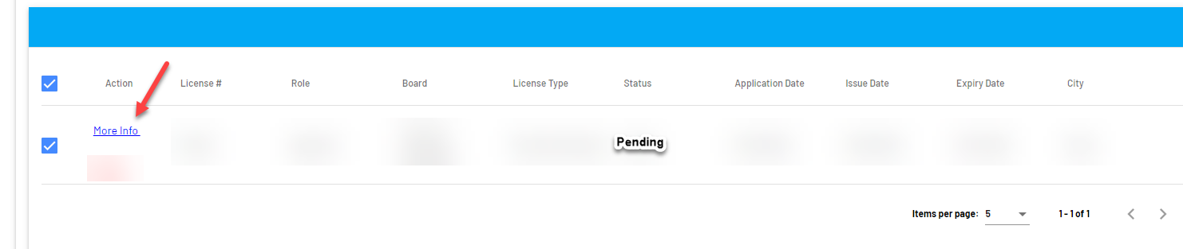

On the next page you will see a License Details section:

In the License details section: click on the word PENDING

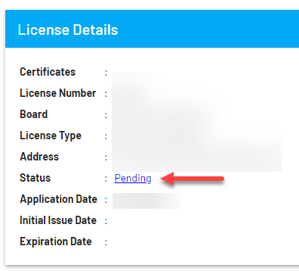

-- It will take you to the License Process Check List. Look under the Application Review section to see items needed or received for licensure. If you have submitted documentation but it still states that NO we have not received it, please check back because the status will change AFTER documents have been REVIEWED. If a document has been received and reviewed but does not meet the criteria, you will see a comment on the right hand side for clarification.

>>As well as directly uploading your documents to your application, checklist items that must come from a primary source can be emailed to [PLPublic@idph.iowa.gov](mailto:PLPublic@idph.iowa.gov) we will attach them to your record.<<