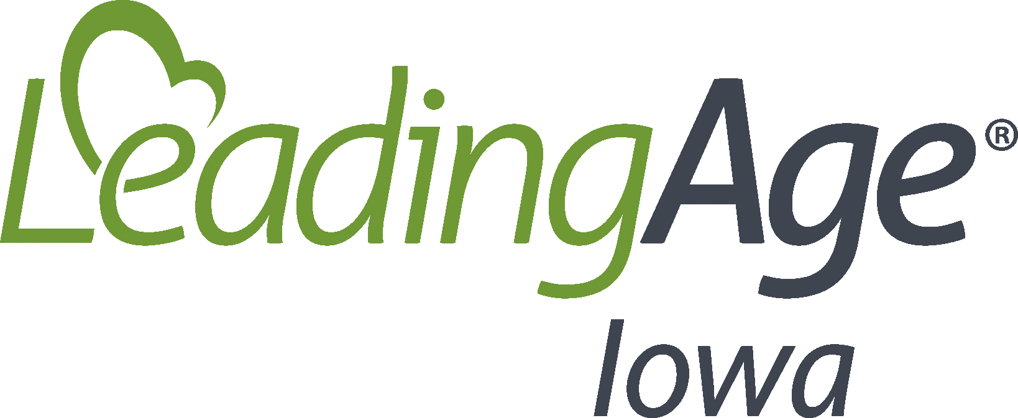

Top 10 Communications Practices During COVID-19

- Communicate. Communicate. Communicate. You cannot over-communicate with family, residents and staff about the precautions you are taking reduce the impact of COVID-19 in your community. Consider communicating through different mediums – letters, emails, phone calls, social media and videos are all vehicles that allow you to reach your community in the ways they best receive information.

- Create a COVID-19 webpage for your website that features the actions you are taking to prevent the virus in your setting and reduce the impact in your community, as well as provide contact information for individuals who have questions and post stories and/or photos that show life inside your setting and the positive engagement and activities you are providing for residents.

- Notify all residents and families when you are informed of a positive case in your setting through your communication channels. This notification should happen each time you are notified that you have a positive case – either resident or staff - in your setting.
  - Consider using automated phone or email apps like Voice Friend and Informacast to automatically send updates to residents and families.

- Designate a staff person to be a primary point of contact for residents and families.

- For a resident who is COVID-19 positive, contact family members each day to keep them informed of their loved one’s status if they are recovering in your setting each day or check in with them if their loved one is being treated in a hospital or other location.

- Post a Situation Update to your COVID-19 webpage each day.

- Send an email newsletter and/or message each week about the status of your operations, activities from the week, photos of residents and staff, and a reminder of the precautions you are taking to keep residents and staff safe. You could also post this information to your webpage and direct families to the webpage with a brief email message each week.

- Help facilitate communication in a variety of ways between residents and families.

- Involve family members by asking what is most important for them to know about their loved ones during this time, or what you should know about their loved one to help engage them and meet their needs.

- Care for the Caregiver. Don’t forget to communicate with your staff. Share a daily update with them on the good work that is taking place in your community and any changes you are making in your operations or service delivery as a result of COVID-19 and potential positive cases in your setting. Thank them for all that they are doing to keep residents safe. Make sure they know who they can talk to if they have concerns or questions.

