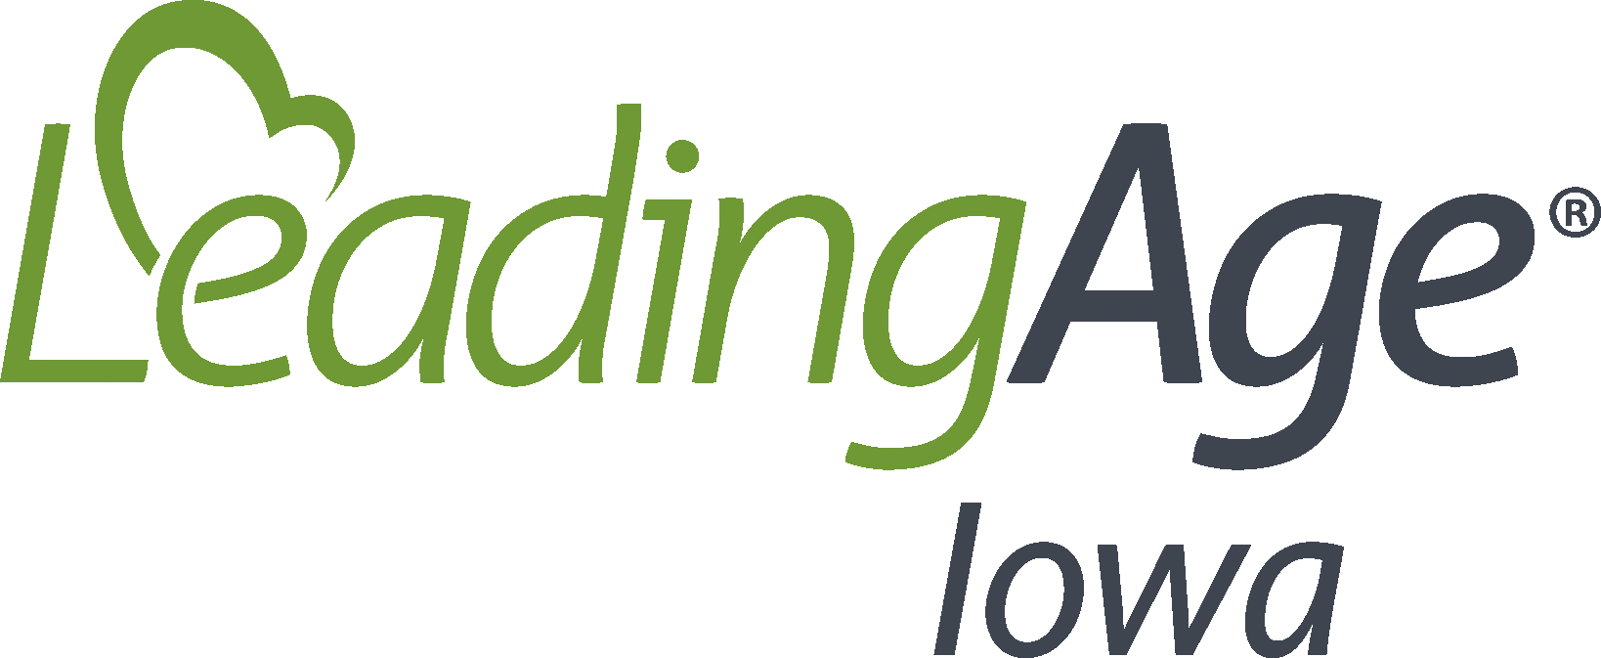
Infection Surveillance, Recording, and Reporting Surveillance Information
Date Implemented:
Review/Updated Date:
Policy
The purpose of infection surveillance is to identify infections and to monitor adherence to recommended infection prevention and control practices in order to reduce infections and prevent the spread of pathogens among residents, staff and visitors.
Surveillance data is utilized to:
- Monitor for trends in infections and identify outbreaks;
- Monitor staff adherence to infection prevention and control practices;
- Identify performance improvement opportunities;
- Track progress toward priorities identified by the QAPI/QAA committee and the infection prevention risk assessment.
Infection Surveillance is the ongoing, systematic collection, analysis, interpretation and dissemination of data and is a core activity of an effective infection prevention and control program.
Process Measures identify specific practices for monitoring staff adherence to infection prevention and control policies and procedures. Surveillance is conducted through audits of practice by direct observation or review of documentation. An example of process measure surveillance is observation of hand hygiene practices among staff, PPE donning and doffing and reviewing antibiotic orders for appropriate indications of use.
Outcome Measures identify specific infection events to monitor among residents and staff and assist with identification of outbreaks.
Comprehensive Surveillance tracks every infection event that occurs among the entire resident and staff population.
Targeted Surveillance focuses on high risk or high consequence infection events such as C-diff.
Surveillance Plan defines the focus areas of surveillance activities and ensures consistency in surveillance activities. In order to develop a surveillance plan infection preventionist should:
- Assess the population on which surveillance is occurring;
- Selecting the outcome measures for monitoring;
- Using surveillance definitions noted above;
- Collecting surveillance data;
- Calculating and analyzing surveillance rates;
- Apply risk stratification methodology;
- Reporting and utilizing surveillance information as a part of the programs QAPI and QAA program.
Procedures
The infection preventionist shall complete an Infection Prevention Risk Assessment annually (a sample risk assessment can be found here).
Based on the results of the risk assessment the infection preventionist will develop a surveillance plan for the facility. The surveillance plan will outline:
- How data collection will occur including the type of surveillance methods used for infection events and locations, staff, and frequency of process measure surveillance.
  - Data collection should be consistent and complete.
  - Identify the staff responsible to collect the data.
  - Utilize tools and resources to standardize the data collection process.
- Standard criteria to define each outcome and process measures.
  - Standardized criteria can be based on the facility preference. Some examples include tracking on NHSN (CDC’s National Health Safety Network) or McGeer Criteria.
- Ensure accuracy, reproducibility and ability to compare the data overtime for trends or potential outbreak identification.
Calculations:
- When surveillance data is tracked for the period of time specified in the plan calculations must be completed on the identified areas and reported to the QAPI/QAA team during regularly scheduled meetings and as necessary.
- Rate calculations should include a formula similarly to a numerator divided by the denominator x constant. Examples include # of events/infections divided by the number of resident days x 1000 = infection rate for the month. Another example is for UTI’s present in residents with indwelling catheters. If 5 residents had a UTI with a catheter present you would use 5 divided by the number of catheter days in all residents x 1000.

Risk Stratification Methodology:
- The process of dividing or classifying into categories to assist with interpretation of findings.
- Infection surveillance data should be stratified according to the type of infection or pathogen.
- Performance monitoring data might be stratified according to the staff being observed or the locations where monitoring was conducted.
- Stratifying surveillance data helps to identify where prevention opportunities might be the greatest.
Rates of infections or performance monitoring are most informative when followed over time. This provides the most accurate estimate of the occurrence of events at a baseline and whether or not process improvements or outbreaks are occurring and/or whether changes need to be made. The baseline rates are best if calculated over a 6-12 month period and serves as a standard for comparison as increases can be a signal for a need to investigate potential causes.
Rates can be shared with the facility QAA/QAPI team during meetings, residents and/or families during council meetings, facility leadership and frontline staff. During performance improvement projects rates can demonstrate to frontline staff improvements in processes occurring and need for continuing practices to maintain resident/staff health and well-being.
The QAA/QAPI team should provide feedback to the infection preventionist based on reports identified areas such as further surveillance activities, process improvement areas, PIP projects.

Resources
CMS. (2017, Nov. 2). State Operations Manual, Appendix PP – Guidance to Surveyors for Long Term Care Facilities, F880. https://www.cms.gov/Medicare/Provider-Enrollment-and-Certification/GuidanceforLawsAndRegulations/Downloads/Appendix-PP-State-Operations-Manual.pdf
CDC. (2020, June 10). Infection Prevention Training | LTCF. https://www.cdc.gov/longtermcare/training.html

